
RAJALAKSHMI INSTITUTE OF TECHNOLOGY
(An Autonomous Institution, Affiliated to Anna University, Chennai)

DEPARTMENT OF ARTIFICIAL INTELLIGENCE AND DATA SCIENCE
ACADEMIC YEAR 2025 - 2026
SEMESTER III
ARTIFICIAL INTELLIGENCE LABORATORY
MINI PROJECT REPORT

REGISTER NUMBER | 2117240070053
NAME | DEVESH A
PROJECT TITLE | ROCK , PAPER , SCISSOR , USING DECISION MAKING ALGORITHM
DATE OF SUBMISSION | 29\10\2025
FACULTY IN-CHARGE | Mrs. M. Divya

Signature of Faculty In-charge

INTRODUCTION
This project demonstrates a simple Rock–Paper–Scissors game developed using Python. It allows the user to play against the computer, which makes its choice using the random module. The program uses conditional statements to compare the user’s and computer’s choices and displays the result as win, lose, or tie. This project highlights the use of basic AI decision-making and logic implementation in Python programming.
PROBLEM STATEMENT
- The goal is to design a simple game where a computer and a user play Rock–Paper–Scissors. The challenge is to enable the computer to make fair and unpredictable choices, creating an engaging and realistic experience for the user.

THEORETICAL BACKGROUND
The Rock–Paper–Scissors game demonstrates the basic concept of Artificial Intelligence in decision-making through randomization and conditional logic. The program uses Python’s random module to allow the computer to make unbiased and unpredictable choices, simulating human decision-making behavior. The use of conditional statements (if-elif-else) helps the system evaluate and decide the game result logically based on predefined rules
ALGORITHM EXPLANATION WITH EXAMPLE
- Start the program.
- Initialize a list containing ["rock", "paper", "scissors"]
- Prompt the user to enter their choice.
- Check if the user’s input is valid (rock, paper, or scissors).
- Use the random.choice() function to let the computer choose one option from the list.
- Display both the user’s and computer’s choices.
- Compare the choices using conditional statements:
- If both choices are the same → It’s a tie.
- If user chooses rock and computer chooses scissors, user wins.
- If user chooses scissors and computer chooses paper, user wins.
- If user chooses paper and computer chooses rock, user wins.Otherwise, user loses.
IMPLEMENTATION AND CODE
import random

choices = ["rock", "paper", "scissors"]

user_choice = input("Enter your choice (rock/paper/scissors): ").lower()

if user_choice not in choices:
print("Invalid choice! Please choose rock, paper, or scissors.")
else:
computer_choice = random.choice(choices)
print(f"\nYou chose: {user_choice}")
print(f"Computer chose: {computer_choice}\n")
if user_choice == computer_choice:
print("It's a tie!")
elif (user_choice == "rock" and computer_choice == "scissors") or \
(user_choice == "scissors" and computer_choice == "paper") or \
(user_choice == "paper" and computer_choice == "rock"):
print("You win! 🎉")
else:
print("You lose! 😢")
OUTPUT

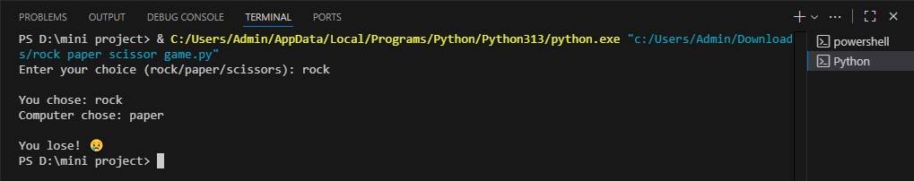

RESULTS AND FUTURE ENHANCEMENT
- In the future, this project can be enhanced by integrating machine learning to predict user choices, adding a graphical user interface (GUI) for better interaction, and maintaining a scoreboard to track multiple rounds.

Git Hub Link of the project and report | https://github.com/Arjun240025/AI_MINI-PROJECT/blob/main/AI%20src%20code
REFERENCES
- 1. Python Official Documentation – https://docs.python.org/3/.
- 2. W3Schools Python Tutorial – https://www.w3schools.com/python/
- 3. GeeksforGeeks – Python Programming Language – https://www.geeksforgeeks.org/python-programming-language/
- 4. TutorialsPoint – Python Programming – https://www.tutorialspoint.com/python/index.htm
- 5. Programiz – Python Tutorial – https://www.programiz.com/python-programming

